Use-Case Realization Report
AddDap

Issue <1.0>
Revision History
Date | Issue | Description | Author
<02/mmm/yy> | <1.0> | <AddDAP> | <Karen Gao>

Table of Contents
1. Brief Description 4
2. Flow of Events 4
2.1 Standard Flow 4
2.2 Exceptions 4
3. Interaction Diagrams 4
3.1 Collaboration Diagram for Add Dap 4
4. Participating Objects 5
5. Class Diagrams 5
5.1 Class Diagram for Add Dap 5
6. Derived Requirements 5

Use-Case Realization Report
AddDap

Brief Description
This is the addition of the DAP by the Portal Administrator. It shall check for duplicate entry before adding the DAP.

Flow of Events

Standard Flow
This use case covers the events of adding DAP, which is part of the maintenance Dap package. The standard flow of events is described as below:
- The Portal Administrator shall press the button to send out a command of “AddButtonClicked” on the interface of MaintainDapPage.
- The operation checkDap will check for the duplication of entries in the DapController.
- Then the operation getModuleDataList shall get Module data list from MuduleData object.
- Subsequently the DapController shall assign the new DAP to the DAP object and display the DAP list on the MaintainDapPage through the operation showDapList.

Exceptions
If the duplication of entry found, a message will be sent to the MaintainDapPage through the operation showDapDuplicated.

Interaction Diagrams

Collaboration Diagram for Add Dap
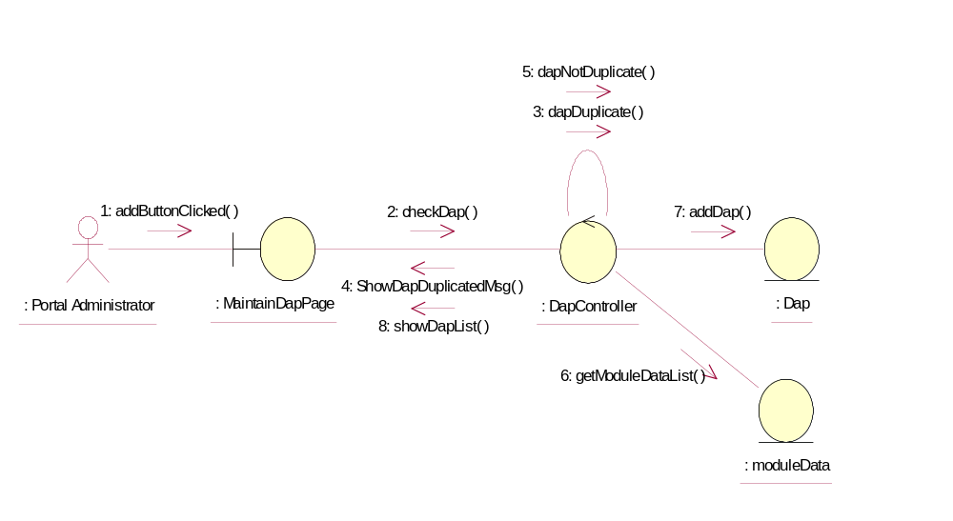

Participating Objects
: Dap
This Entity is Dap object

: DapController
This controller is to add, delete and update Dap

: MaintainDapPage
This is a page for adding, deleting, updating and displaying Dap

: moduleData
This Entity is ModuleData object

: Portal Administrator
This is the super user of the system.

Class Diagrams

Class Diagram for Add Dap
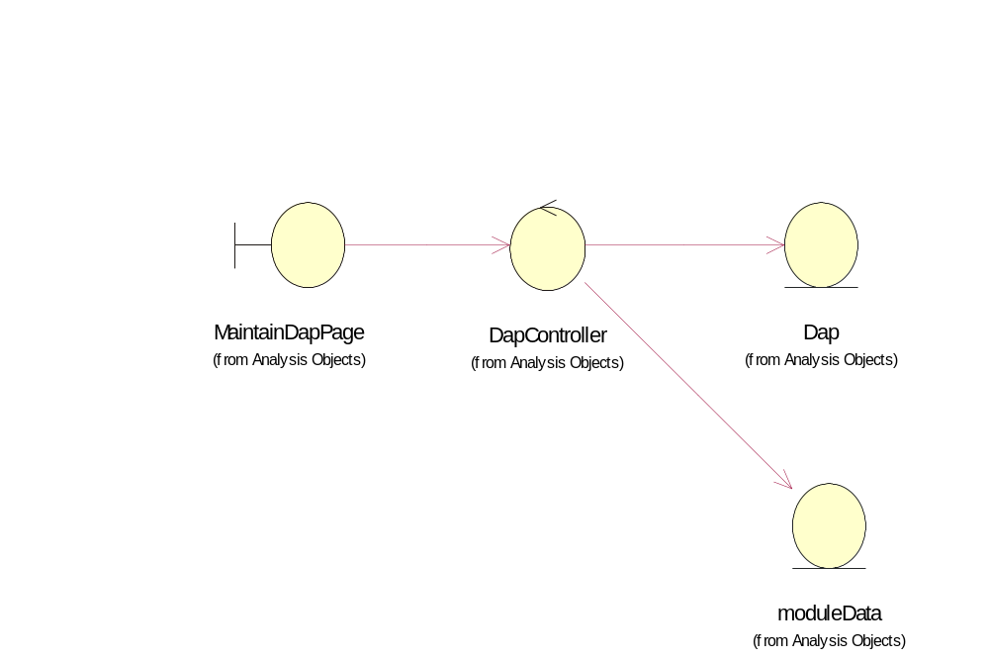

Derived Requirements
Only Portal Administrator has rights to access this page.

